

**REPORT FOR**

**Python Mini Project**

AS A PROJECT WORK FOR THE COURSE

**PYTHON PROGRAMMING (INT 108)**

**NAME:** Mo Sahil

**REGISTRATION NUMBER:** 12216811

**ROLL NUMBER:** A07

**SEMESTER:** FIRSTSEMESTER

**DATE OF SUBMISSION:30/12/22**

**SUBMITTED TO: Ms. Manbir Kaur**

**SCHOOL OF COMPUTER SCIENCE AND ENGINEERING**

**LOVELY PROFESSIONAL UNIVERSITY, JALANDHAR, PUNJAB, INDIA.**

**DECLARATION**

This is to declare that this report has been written by me. No part of this report is copied from other sources. All information included from other source has been duly acknowledged. I aver that if any part of the report is found to be copied. I shall take full responsibility for it.

**Mo Sahil**

**12216811**

**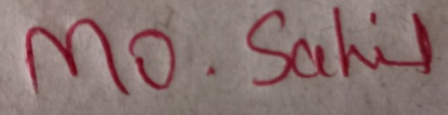**

**INDEX**

* 1. **INTRODUCTION**
  2. **LOOPS/FUNCTION**
  3. **PROJECT**
  4. **CODE**

**1.5 RESULT**

**PYTHON**

* 1. **INTRODUCTION:**

This program counts the number of prime and composite numbers in a given range. A prime number is a positive integer greater than 1 that has no positive integer divisors other than 1 and itself. A composite number is a positive integer that has at least one positive integer divisor other than 1 and itself. For example, 2, 3, 5, and 7 are prime numbers, while 4, 6, 8, and 9 are composite numbers.

* 1. **LOOPS/FUNCTION:**

In this program I used if, elif and else conditions, for loop, input and print function. With if, elif and else conditions I checked when to count or not to count prime and composite functions. I used for loop to count prime and composite functions in user given range. With input function I took input for range from the user and with print function I printed the resut.

* 1. **PROJECT :**

First I took two inputs from user for the range in which we have to count prime and composite functions.Screenshot_20221228_041118.png

Then I initialised two variables prime and composite, which I used to count prime and composite functions.Screenshot_20221228_041235.png

Then I wrote an if condition Screenshot_20221228_041311.png

Then I used a for loop under this if condition to define range for my operations under which i wrote code to count prime and composite functions.

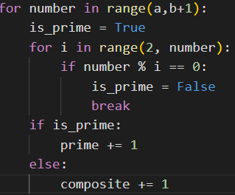

After it I wrote two if and elif conditions for exceptional cases of 0 and 1.

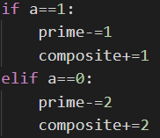

**1.5 CODE:**

a = int(input("Enter starting range: "))

b = int(input("Enter ending range: "))

prime = 0

composite = 0

if a >= 0 and a < b:

    for number in range(a, b+1):

        is\_prime = True

        for i in range(2, number):

            if number % i == 0:

                is\_prime = False

                break

        if is\_prime:

            prime += 1

        else:

            composite += 1

    if a==1:

        prime -= 1

        composite+=1

    elif a==0:

        prime -= 2

        composite += 2

    print("There are",prime,"prime and",composite,"composite numbers in given range")

else:

    print("Enter Valid Range")

* 1. **RESULTS:**

****

**

